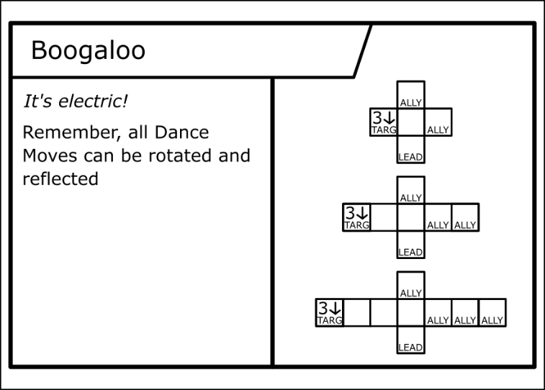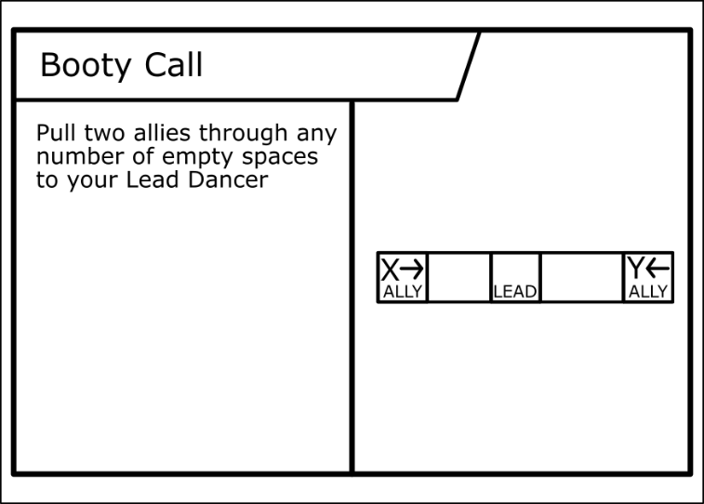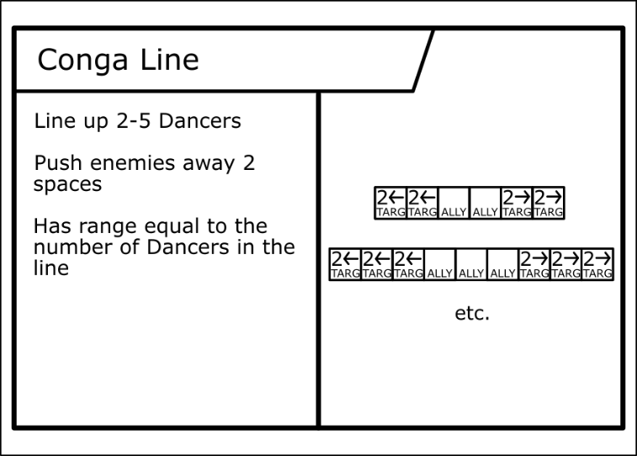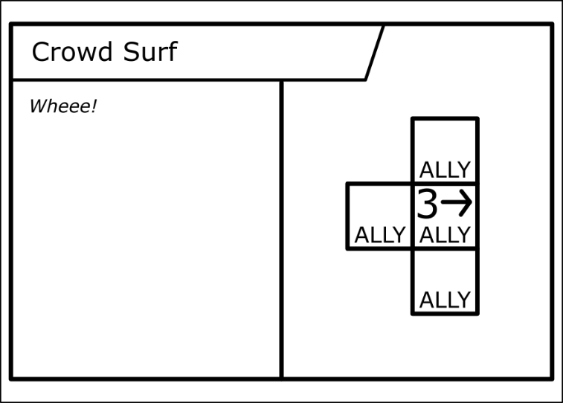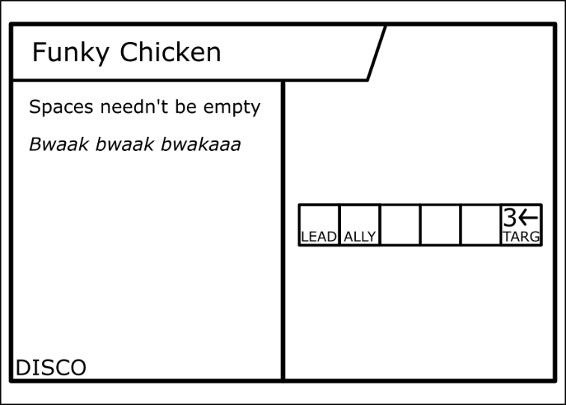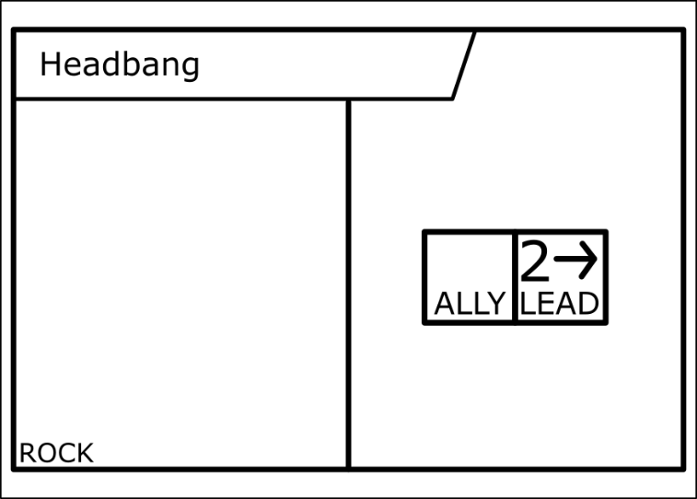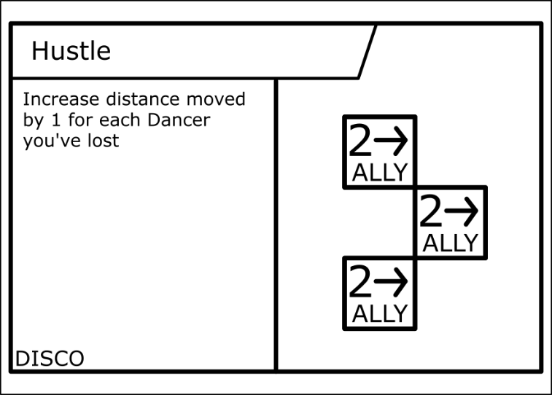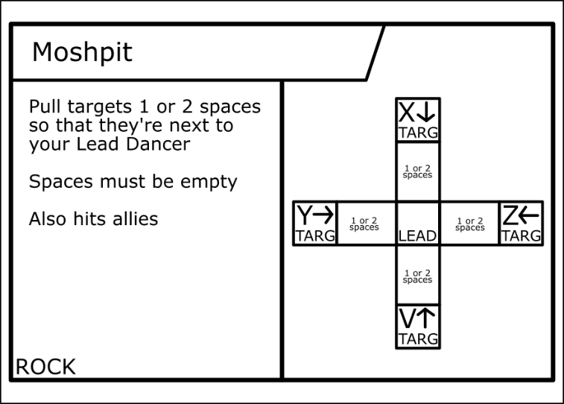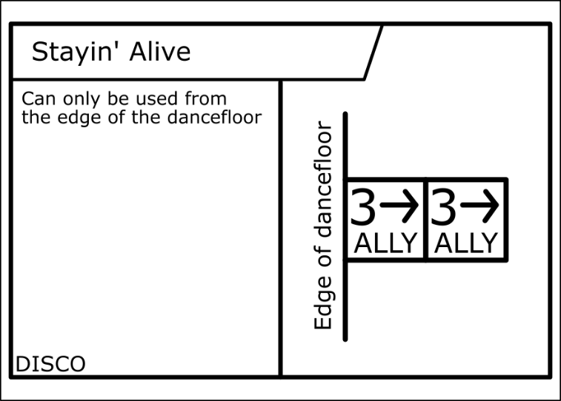

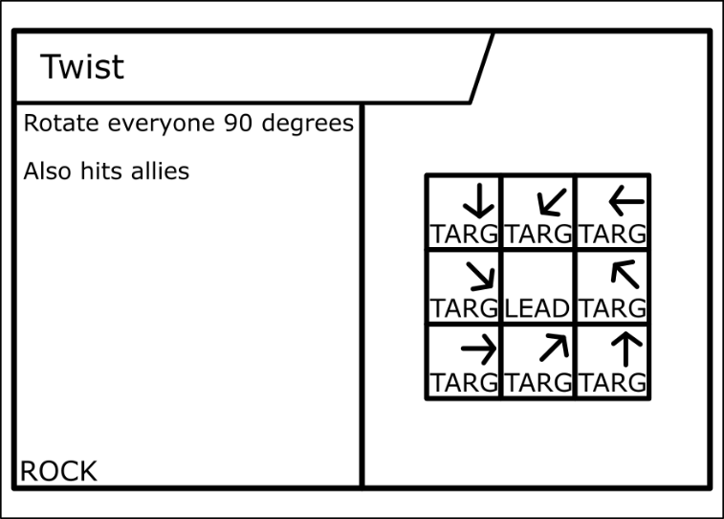

**AFRO DISCO**

Movement

Each turn you may move all of your Dancers 2 spaces, or 1 space diagonally.

Dance Moves

At any time during your turn, you may activate one of your Dance Move cards. Lead and Backup Dancers must be in the correct positions, “allies” are any Dancer you control.

If a Dance Move moves a Dancer into another Dancer, they are pushed.

Each Dancer Move may be used only once per turn.

Winning the game

If a Dancer is moved off the dancefloor, they are removed from the game.

To win, remove your opponent’s Lead Dancer or all their Backup Dancers from the dancefloor.

Deckbuilding

A deck is 4 cards. You may only use neutral cards and cards from one era (Disco, Rock, etc.). There can be no duplicates in a deck.